GIT AND GIT HUB

1)Install git.

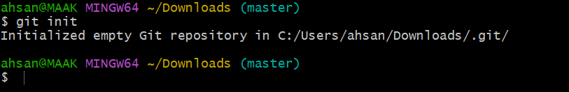
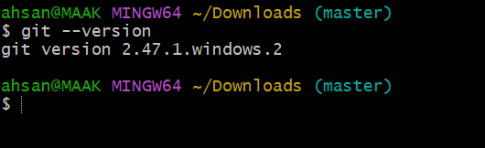
2)Create a repo in github with README.md and .ignore file.
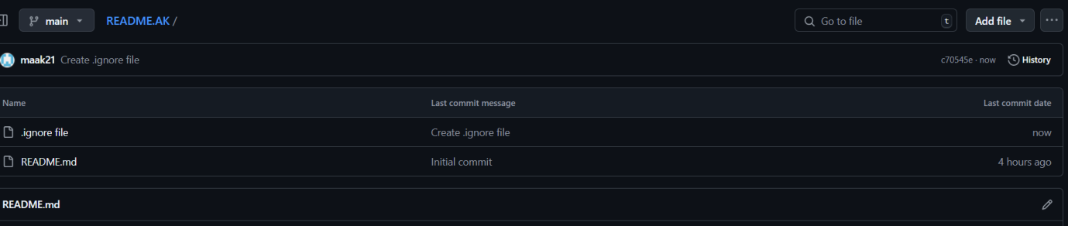
3)Clone the created repo to local.
• Go to your repository on GitHub.
• Click the "Code" button (usually green) on the repository page.
• Copy the URL provided:
- For HTTPS:
https://github.com/maak21/README.AK.git
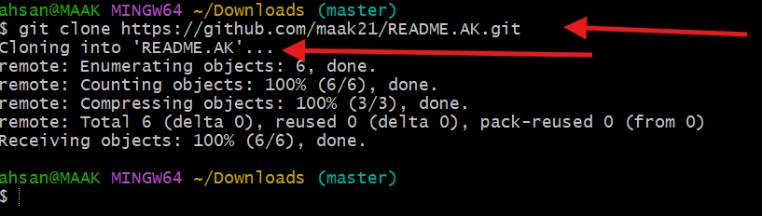
4)Create two files in local repo.
cd README.AK
touch frist second
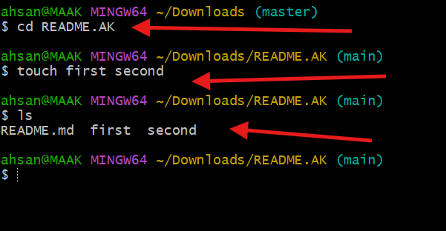
5)Commit two files and push to central Repository.
First check status of git
Git status
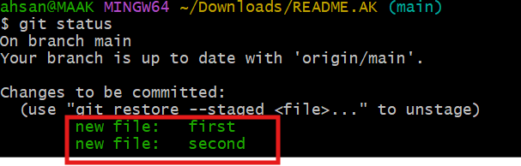
git commit -m "Added files: frist and second"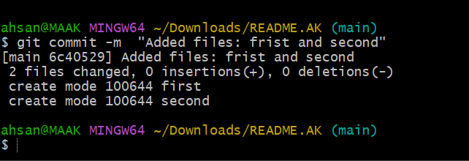
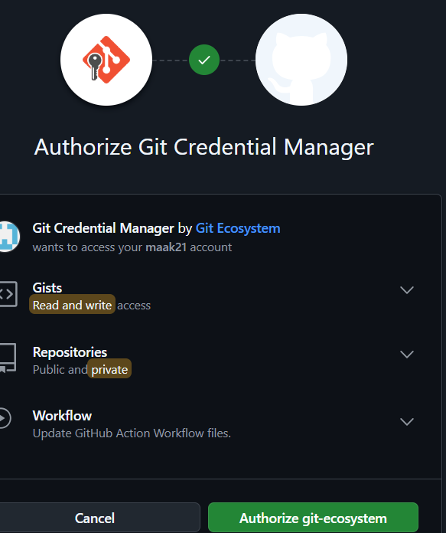
git push origin main
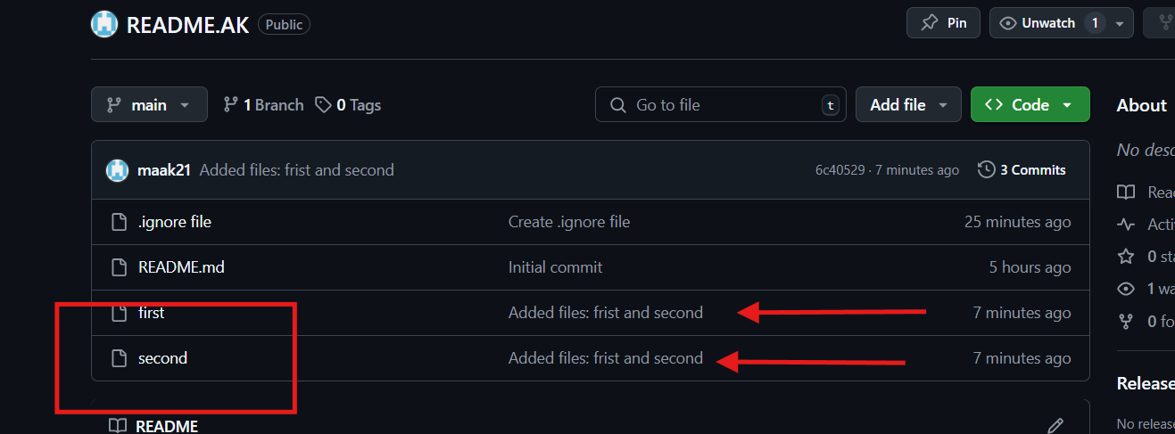
6)Create a branch in local and create a sample file and push to central.
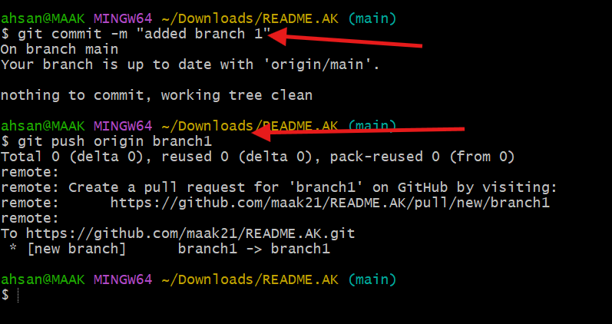
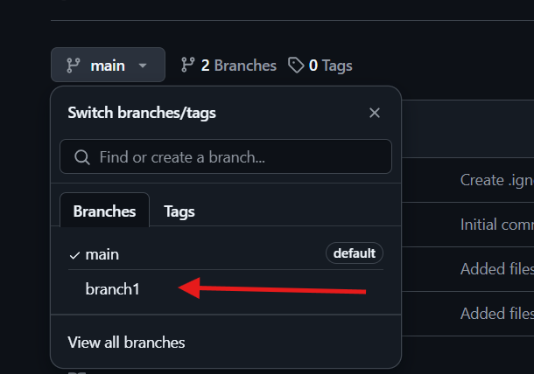

7)Create a branch in github and clone that to local.

Step 1: Create a Branch in GitHub
- Go to your repository on GitHub.
- Click the "Code" tab to view your repository files.
- Look for the branch dropdown (usually says main) and click it.
- In the text field, type the name of the new branch (e.g., new-branch) and press Enter.
  - Ensure the "Create branch" option is selected when pressing Enter.

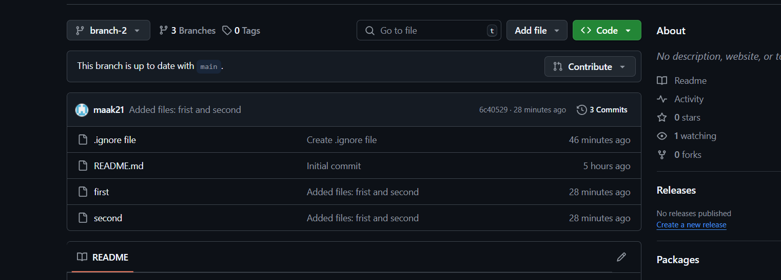

Step 2: Clone the Repository Locally
If you haven’t cloned the repository yet:
- Copy the repository URL from the Code button.
- Open Git Bash and run:
Step 3 git clone https://github.com/maak21/README.AK.git
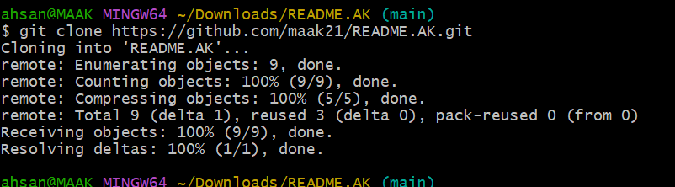

Step 3: Checkout the New Branch
Now that the repo is cloned:
- Fetch the latest branch information:
- • git fetch
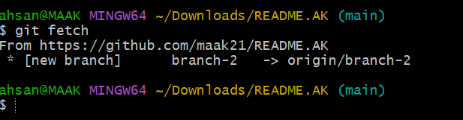
git checkout branch-2
git branch
git branch –-list
git commit -m README.AK

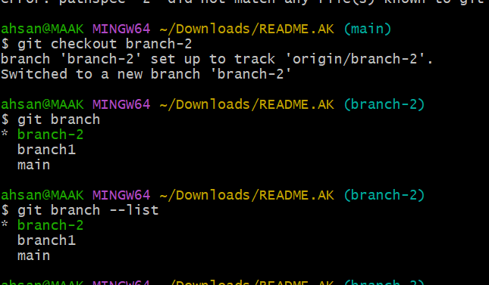
8)Merge the created branch with master in git local.

Step 1: Switch to the main Branch
First, make sure you’re on the main branch where you want to merge the changes:
Switch to main brach
$Git checkout main
$ git merge brach-2
Updating 6c40529..cda8c69
Fast-forward
README.AK | 1 +
1 file changed, 1 insertion(+)
create mode 160000 README.AK

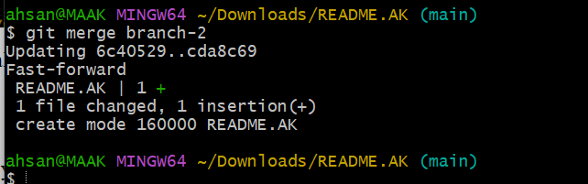

9)Merge the created branch with master in github by sending a pull request.

Step 1: Go to the Repository on GitHub
- Open your repository on GitHub (e.g., README.AK).
- Ensure your changes have been pushed to the remote branch (e.g., branch-2).

Step 2: Start a Pull Request
- Click the "Pull requests" tab in your repository.
- Click the "New pull request" button.

Step 3: Select the Branches

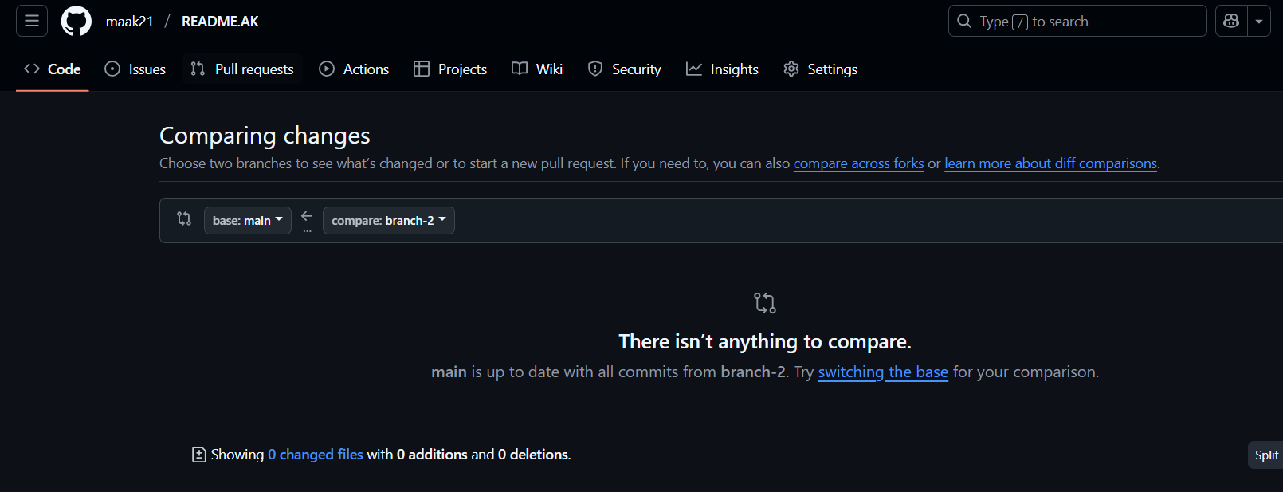

- In the "base" dropdown, select main (this is the branch you want to merge into).
- In the "compare" dropdown, select branch-2 (the branch you want to merge from).

Step 4: Create the Pull Request
- Review the changes below to ensure everything looks correct.
- Add a title and description for your pull request.
  - For example: Title: "Merge branch-2 into main"
  - Description: "This pull request includes [brief description of the changes]."
- Click "Create pull request".

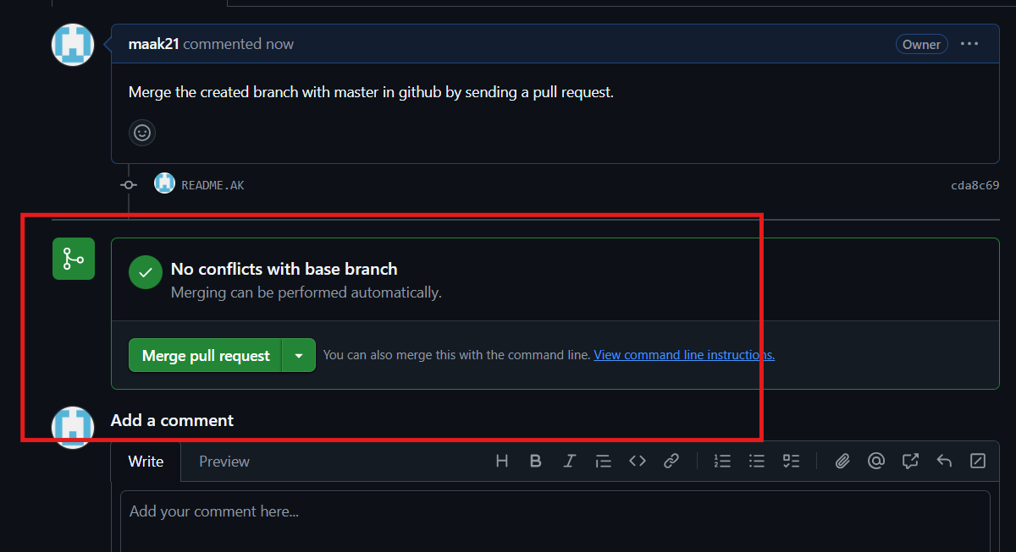

tep 5: Review and Merge
- If the repository is yours, you can review and merge the pull request yourself:
  - Click "Merge pull request".
  - Confirm the merge by clicking "Confirm merge".
- If there are conflicts, GitHub will notify you. Resolve them in the web editor before merging.
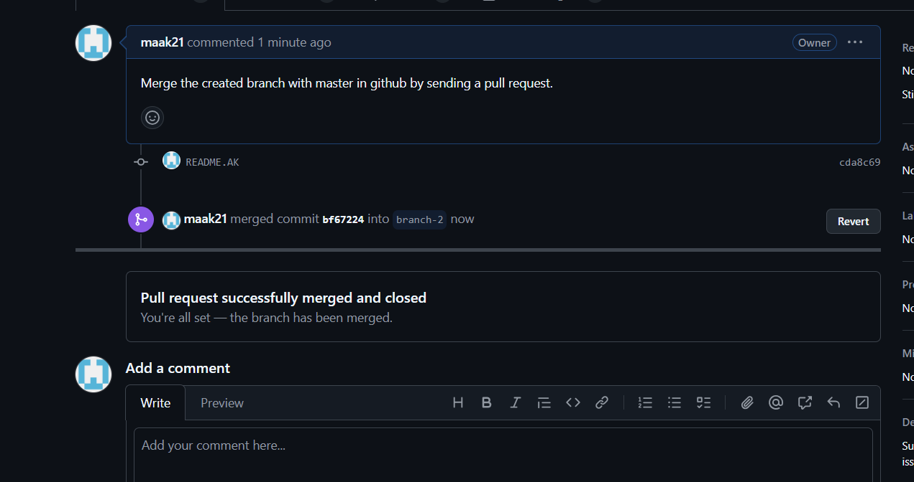

10)create a file in local and send that to branch in github.
Step 1
Git checkout branch -2 ( switch to branch-2)
Touch sample 1 ( created file name sample)
Git add . ( save and excecute)

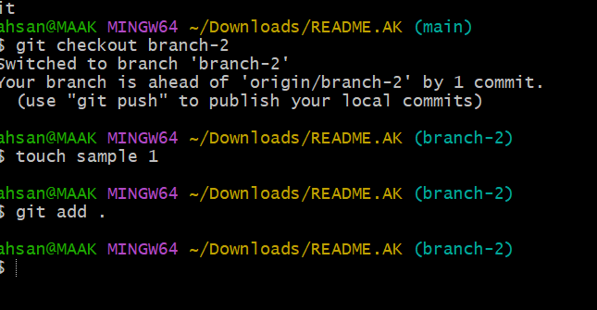
git commit -m "adding sample1 in branc2"
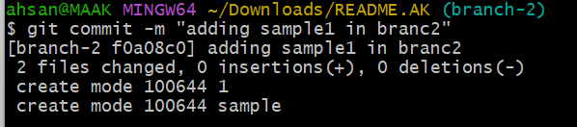
Fetch and integrate the remote changes into your local branch-2:
bash
git pull origin branch-2 –rebase
After successfully rebasing
git push -u origin branch-2

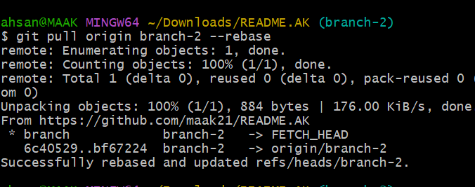
Here we created a file in local and push it to centeral repository of branch2
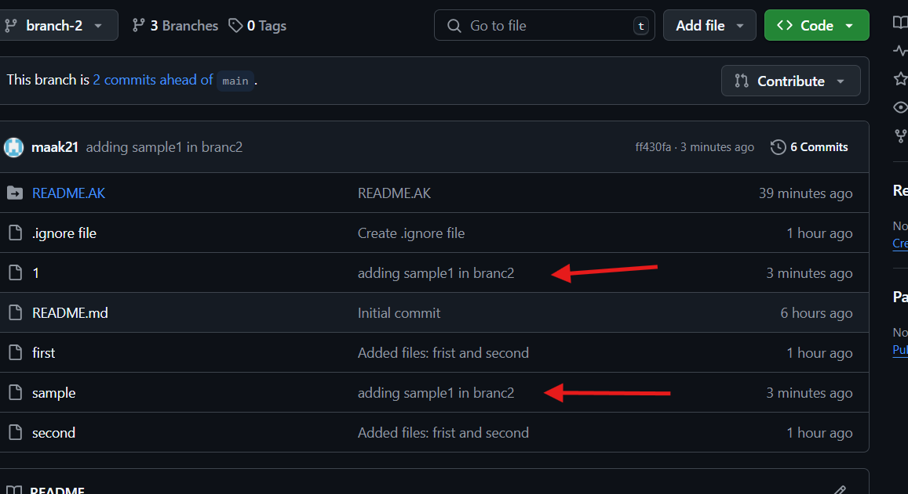
11)clone only a branch from github to local.
Herer what we did clone from github to local
Step1 to switch brach 2
Step 2 for below command mention specific branch name ex: branch 2 then url then give new directory name

git clone --branch branch-2 --single-branch https://github.com/maak21/README.AK.git githubtolocalbrachclone
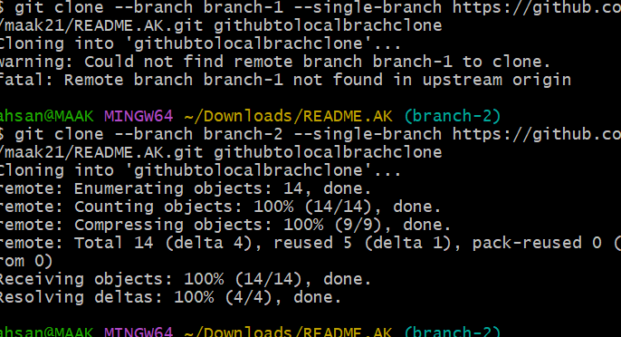
Some are untrack files there now , and git fetch is used now

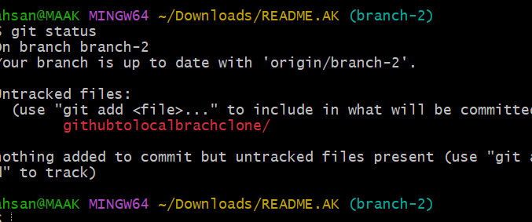

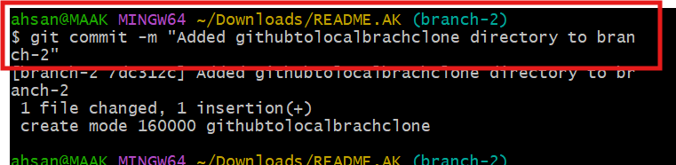
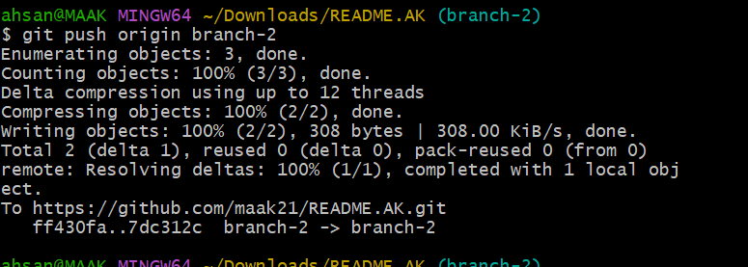
12)create a file with all passwords and make that untrackable with git.

tep 1: Remove the File from Git Tracking
Even though the file is currently tracked, you can stop Git from tracking it while keeping it in your local system:
bash
git rm --cached password.txt
vi. .gitignore
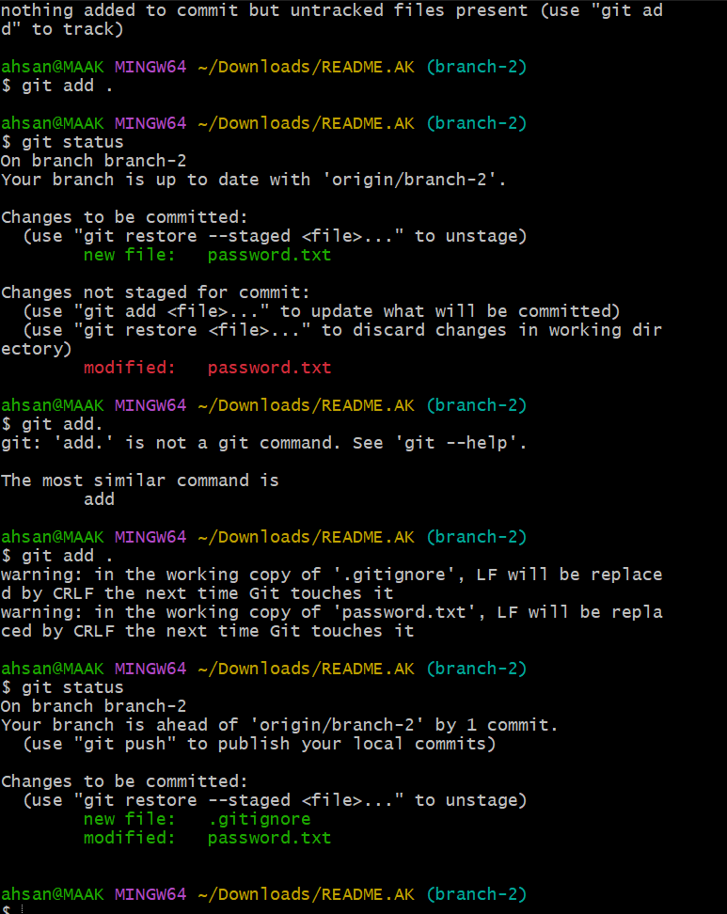
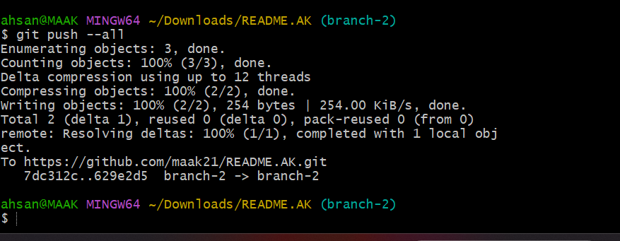
13)make a commit and make that commit reset without savings changes.
14)Revert a commited commit to the older version.
15)push a file to stash without savings the changes and work on another file.
16)undo the stash file and start working on that again.
17)generate a ssh-keygen and configure into github.
18)configure webhooks to github.
19)basic understanding of .git file.
20)Check all the logs of git.
21)Rename the commit message.
22)Merge multiple commits into single commit.

